**Group task**

**Report on Comprehensive Analysis of Attacks on the OSI Model and Case Studies**

Company: Senselearner Technologies Pvt. Ltd.

Name: Adarsh Kumar

Group Name: Hosta

Date: 08/07/2023

Task 1: Attacks on the OSI Model

**Introduction:**

The Open Systems Interconnection (OSI) model is a conceptual model created by the International Organization for Standardization (ISO) that enables diverse communication systems to communicate using standard protocols. It consists of seven different abstraction layers: Physical, Data Link, Network, Transport, Session, Presentation, and Application, each of which has a distinct purpose. Attacks targeting the OSI model can occur at any layer. This report aims to explore attacks at each layer of the OSI model, analyse attack techniques, and assess their impact on network security Organizations should take security precautions for their networks by comprehending how assaults at various stages can weaken network security and damage the entire system.

The report will begin by providing an overview of the OSI model. Then, it will discuss the different attack vectors at each layer of the model. The report will also discuss the impact of these attacks on network security. Finally, the report will present some real-world case studies of attacks targeting the OSI model.

The report is intended to provide a comprehensive overview of attacks targeting the OSI model. It is hoped that this report will help organizations to understand the different attack vectors and the impact of these attacks. By understanding these risks, organizations can take steps to protect their networks from attack.

**The OSI Model:**

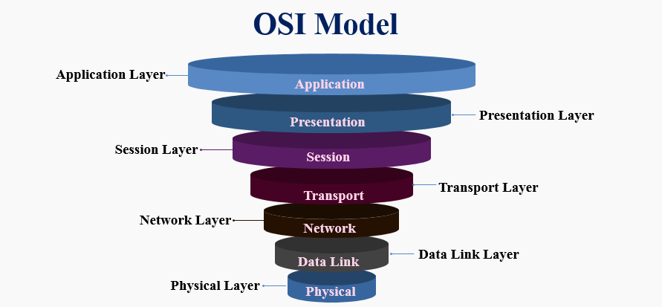

The International Organization for Standardization (IOS) developed the open systems interconnection (OSI) model, a conceptual framework that enables various communication systems to exchange data via mutually agreed-up protocols. The OSI, or Open Systems Interconnection, offers a standard for various computer systems to be able to interact with one another.

One may think of the OSI Model as a common language for computer networking. Its foundation is the idea that a communication system may be broken down into seven abstract levels, each one built on top of the previous.

Working of 7 Layers of the OSI Model

1. **Physical Layer:** The Physical layer is the first layer of the OSI Model. The physical layer works to send individual bits from one node to another. This layer is responsible for the connection between two devices. Whatever data comes to this layer is converted in binary format, i.e., 0’s and 1’s. After converting it, send data to the Data-link layer.

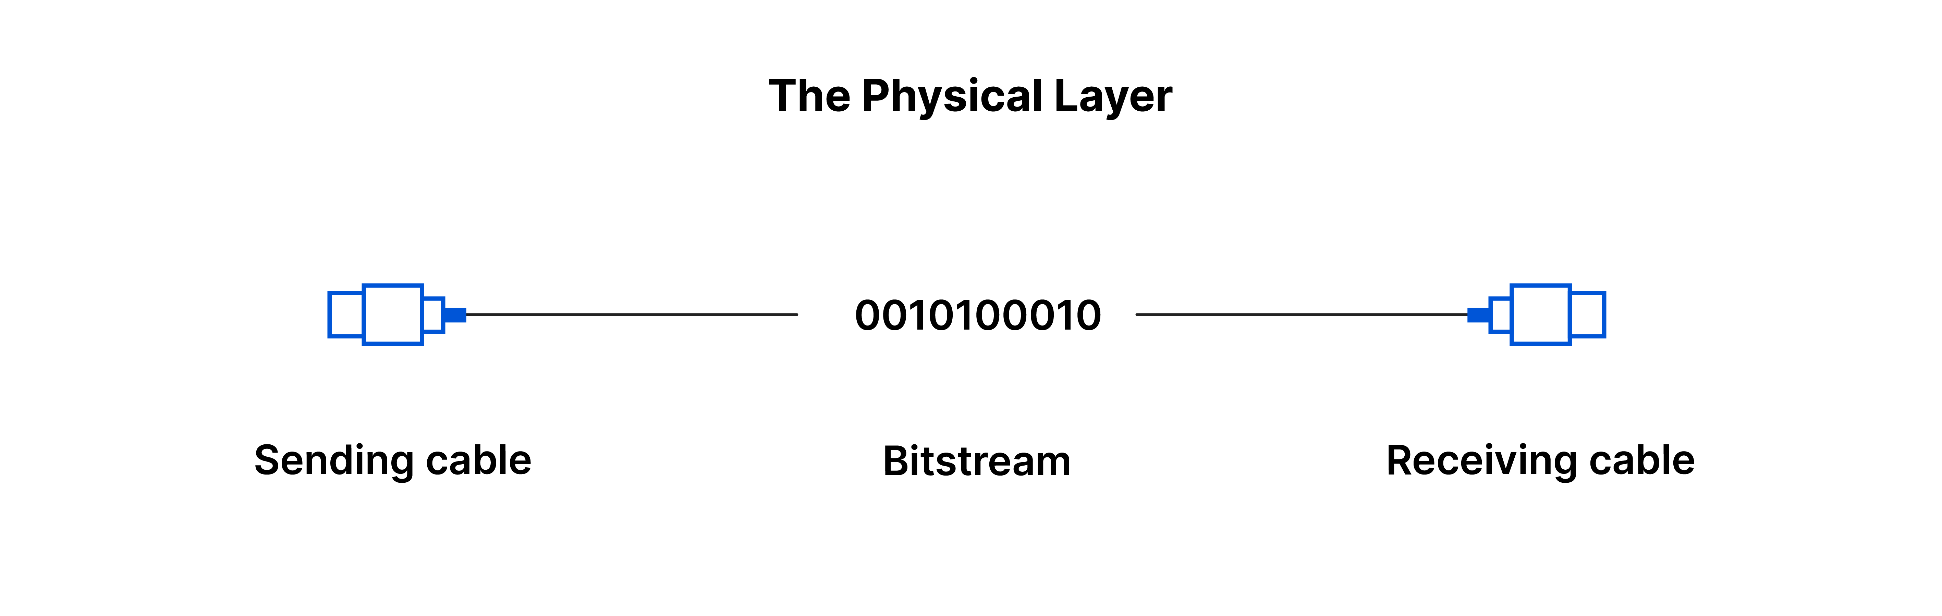

1. **Data Link Layer:** The Data Link layer is the second layer above the model’s Physical layer. The data link layer is responsible for moving frames from one node to the other. This layer makes sure that data received or transferred should be error-free. It also ensures security by attaching some bits at the start and end of the frame.

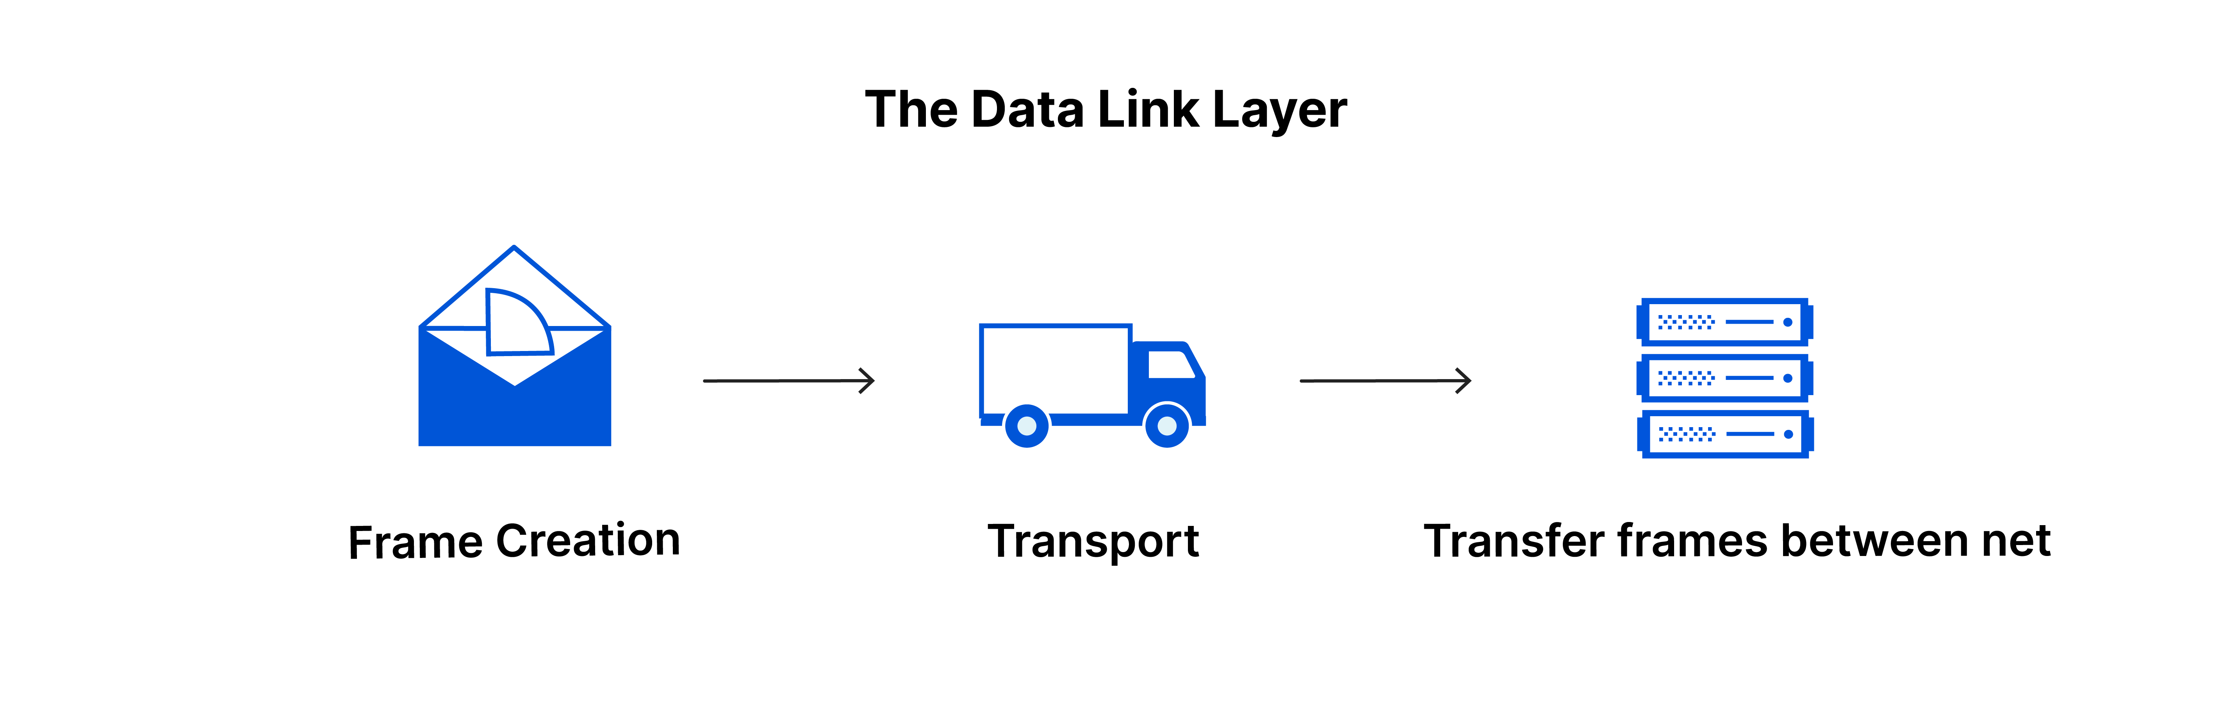

1. **Network Layer:** The Network layer is the third layer of this model. The network layer must deliver the packets from the source node to the destination node. It sends data from one network to another. It makes use of different routing algorithms to send data. The network layer carries an IP address at the header.

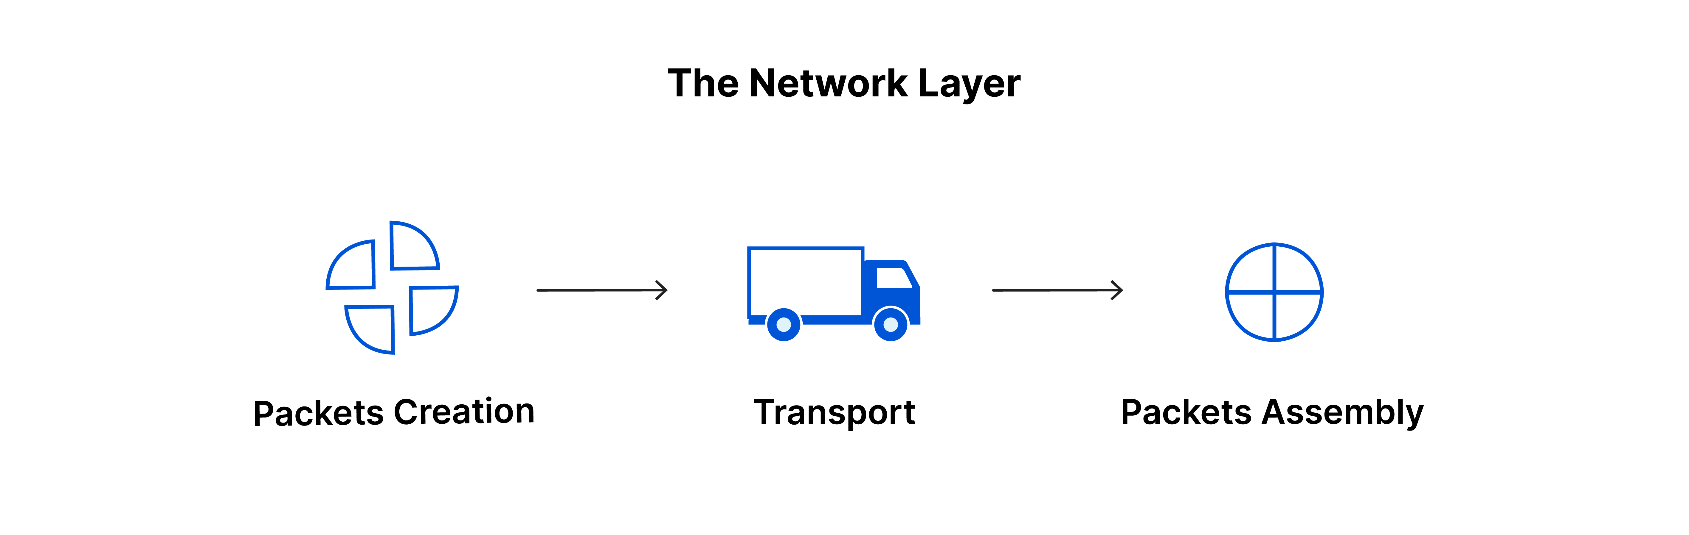

1. **Transport Layer:** The Transport layer is the fourth layer of this model. The transport layer delivers the message from one process to another. It takes data from the network layer and transmits data to the application layer. In this layer, the main thing is acknowledgment. Acknowledgment is the process of data transmission over the network successfully. This layer resides on the operating system of the device. It works with the system calls.

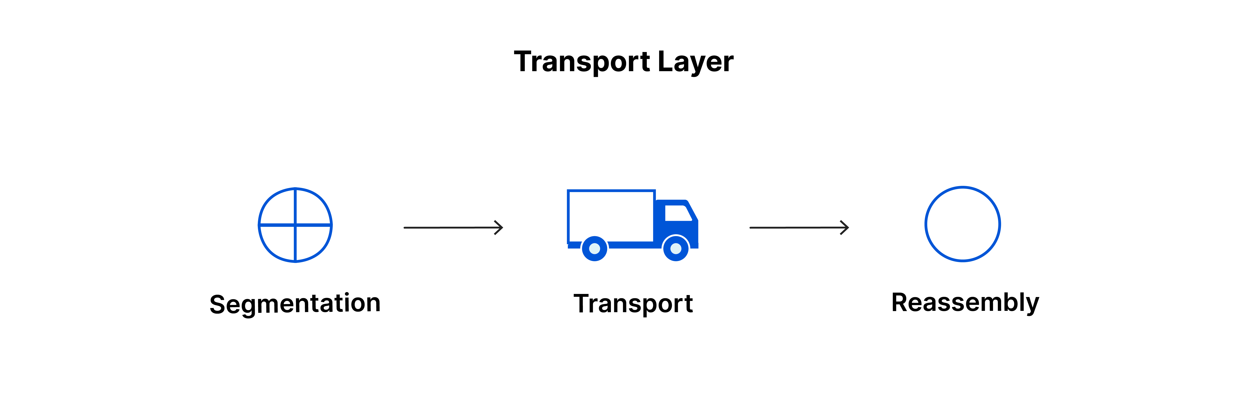

1. **Session Layer:** The session layer is the fifth layer. As the name suggests, this layer manages sessions between end-user application processes.



1. **Presentation Layer:** The presentation layer is the sixth layer. The Translation layer, or the Presentation layer, is responsible for presenting data to the application.

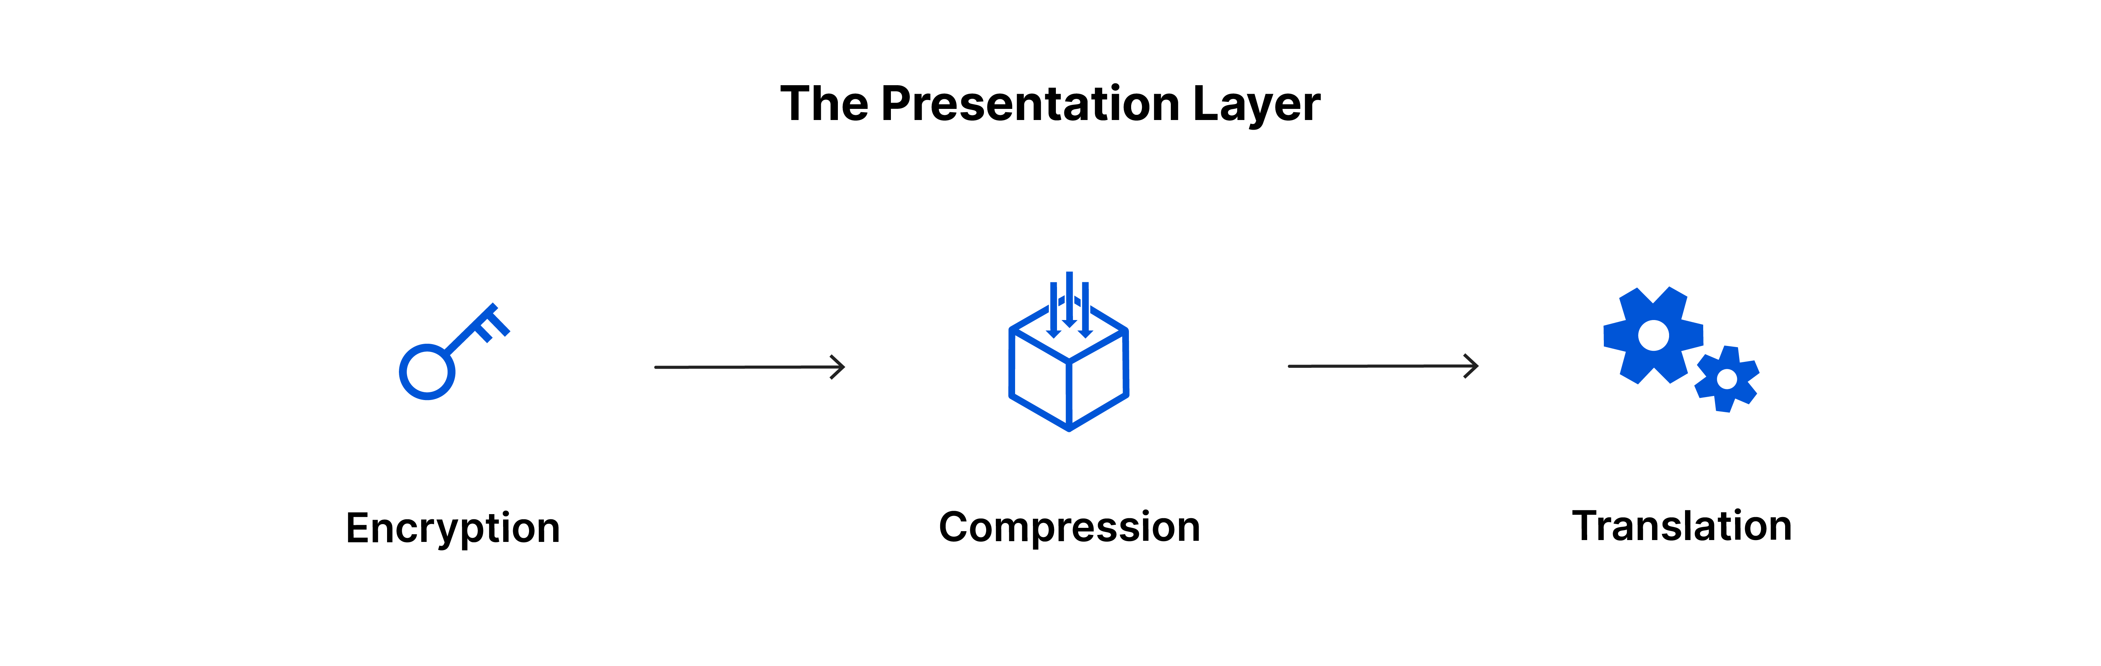

1. **Application Layer:** The Application layer is the last and seventh layer of the OSI Model. This layer is the abstraction layer. Which handles sharing protocols over the computer network with OSI and TCP/IP

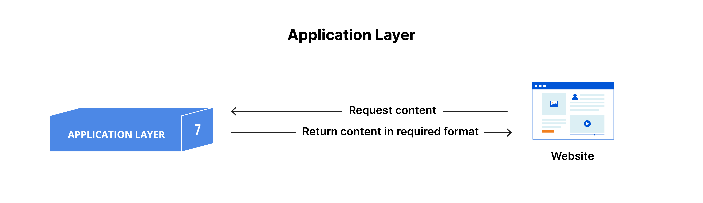

Working of OSI model

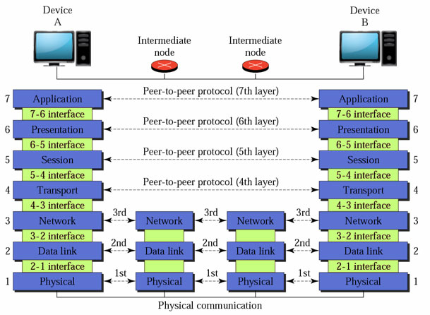

**Attacks on the OSI Model:**

**Physical Layer Attacks:** The physical layer deals with the physical transmission of data. Attacks at this layer focus on compromising the physical components of the network.

Some common physical layer attacks include:

* Cable tampering: Attackers physically cut, tap, or modify network cables to intercept or disrupt data transmission. This can be mitigated by implementing physical security measures such as locked cabinets and tamper-evident seals.
* Hardware manipulation: Attackers modify network devices or replace them with malicious hardware to gain unauthorized access or intercept data. Regular device inspections and purchasing from trusted sources can help mitigate this risk.

**Data Link Layer Attacks:** The data link layer ensures reliable data transfer between adjacent nodes. Attacks at this layer target the communication between these nodes.

Some common data link layer attacks include:

* MAC address spoofing: Attackers impersonate a legitimate device by modifying its Media Access Control (MAC) address. Implementing port security features and using MAC address filtering can help prevent such attacks.
* ARP spoofing: Attackers send falsified Address Resolution Protocol (ARP) messages to associate their MAC address with the IP address of another device, leading to traffic redirection or interception. Implementing ARP spoofing detection and mitigation techniques can minimize the impact of these attacks.

**Network Layer Attacks:** The network layer handles logical addressing and routing of data packets. Attacks at this layer focus on disrupting or intercepting network traffic.

Some common network layer attacks include:

* IP spoofing: Attackers modify the source IP address of packets to impersonate another entity and bypass network security measures. Implementing strong ingress and egress filtering, as well as IP reputation systems, can help detect and prevent IP spoofing attacks.
* Denial of Service (DoS) attacks: Attackers overwhelm network resources to make them unavailable to legitimate users. Employing traffic filtering, rate limiting, and DoS protection solutions can help mitigate the impact of DoS attacks.

**Transport Layer Attacks:** The transport layer ensures reliable data delivery between end-to-end connections. Attacks at this layer exploit vulnerabilities in transport layer protocols.

Some common transport layer attacks include:

* TCP/IP hijacking: Attackers intercept and modify TCP/IP packets to gain unauthorized access or manipulate data. Implementing secure protocols, strong encryption, and intrusion detection systems can minimize the risk of TCP/IP hijacking.
* SYN flooding: Attackers flood a target system with a large number of SYN requests, exhausting its resources and making it unresponsive. Implementing SYN cookies, rate limiting, and firewall rules can help protect against SYN flooding attacks.

**Session Layer Attacks:** The session layer establishes, manages, and terminates sessions between applications. Attacks at this layer aim to disrupt or hijack session-related information.

Some common session layer attacks include:

* Session hijacking: Attackers gain unauthorized control of a session by intercepting or manipulating session tokens or identifiers. Implementing strong session management techniques, secure session tokens, and transport layer security can help prevent session hijacking.
* Man-in-the-middle (MitM) attacks: Attackers intercept communication between two parties, allowing them to eavesdrop, modify, or inject malicious content. Implementing end-to-end encryption, digital certificates, and secure key exchange protocols can mitigate the risk of MitM attacks.

**Presentation and Application Layer Attacks:** The presentation layer handles data encryption, compression, and formatting, while the application layer provides interfaces for end-user applications. Attacks at these layers target vulnerabilities in application protocols or specific software implementations.

Some common presentation and application layer attacks include:

* Cross-Site Scripting (XSS): Attackers inject malicious scripts into web applications, which are then executed by unsuspecting users. Implementing input validation, output encoding, and secure coding practices can help prevent XSS attacks.
* SQL injection: Attackers insert malicious SQL queries into application inputs to gain unauthorized access to databases or execute unintended commands. Employing parameterized queries, input validation, and secure coding practices can mitigate the risk of SQL injection attacks.

**Conclusion:**

Understanding the different layers of the OSI model and the potential attack vectors at each layer is crucial for securing network infrastructure. By implementing appropriate security measures, such as encryption, access controls, and intrusion detection systems, organizations can effectively mitigate the risks associated with attacks targeting the OSI model. Regular vulnerability assessments, monitoring, and staying updated with the latest security practices are essential to ensure network security and maintain the integrity of critical systems.

Most cybercriminals will target a network on one of the seven layers of the OSI, and organizing threats along the different levels can make it easier to think about prevention, detection, and remediation strategies.

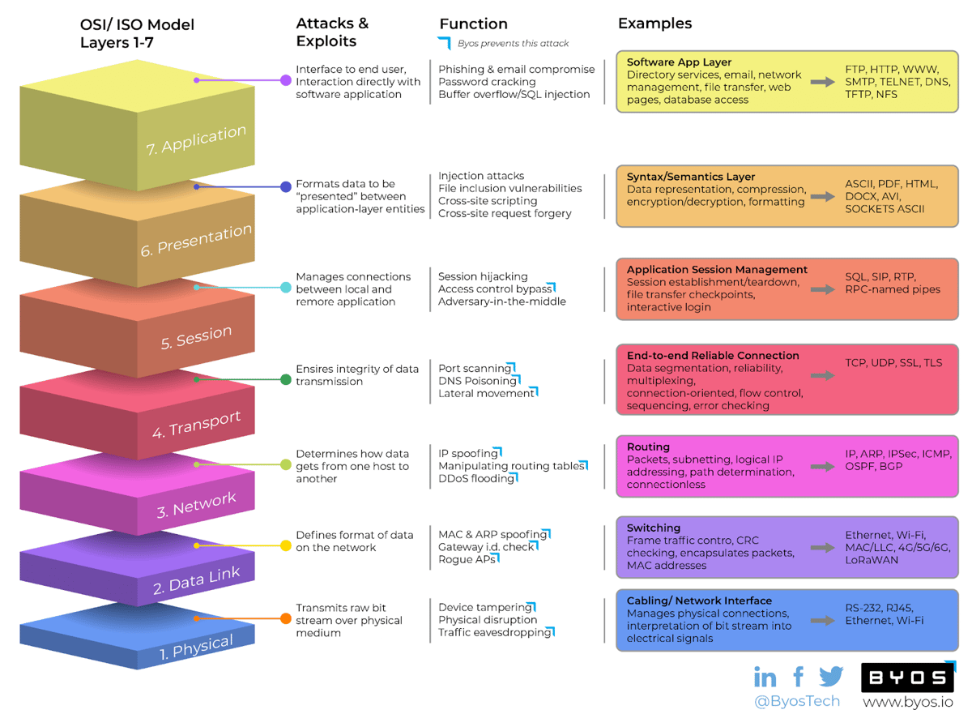

In order to mitigate the risk of attacks targeting the OSI model, it is important to implement security measures at all layers. Some of the most common security measures include:

* **Physical security:** This includes measures such as access control, physical barriers, and environmental controls.
* **Network security:** This includes measures such as firewalls, intrusion detection systems, and network segmentation.
* **Host security:** This includes measures such as antivirus software, patch management, and user training.

By implementing security measures at all layers of the OSI model, organizations can help to protect their networks from attack.

Task 2: Real-World Case Studies

**Title: Case Study of the Mirai Botnet**

**Introduction**

The Mirai botnet represents one of the most notorious and impactful cyberattacks in recent years. The Mirai botnet represents a significant cyber threat that exploited vulnerabilities across multiple layers of the OSI (Open Systems Interconnection) model. This case study delves into the details of the Mirai botnet, including its background, operation, and implications. By understanding the Mirai botnet, we can gain valuable insights into the vulnerabilities it exploited, the damage it caused, and the lessons we can learn from this significant cyber threat.

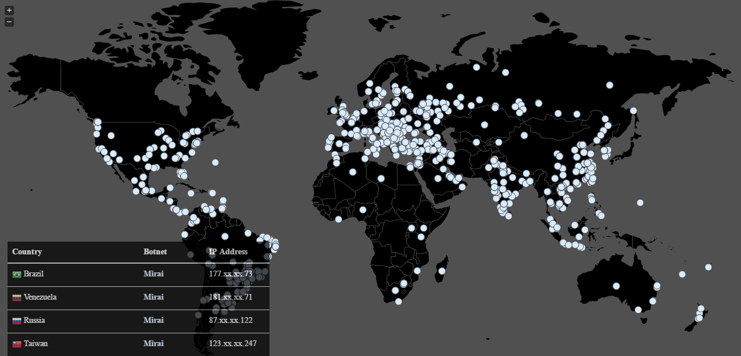

**Background**

The Mirai botnet emerged in late 2016 and quickly gained attention due to its disruptive nature. It targeted Internet of Things (IoT) devices, such as routers, cameras, and digital video recorders (DVRs), which often had weak security measures in place. The botnet was primarily used to launch distributed denial-of-service (DDoS) attacks, effectively taking down websites and online services by overwhelming their servers with a massive volume of traffic.

**Operation and Techniques**

Mirai operated by scanning the internet for IoT devices with weak or default credentials. Once identified, it would attempt to connect to these devices using a list of known username and password combinations. If successful, Mirai would install itself on the compromised device, effectively turning it into a botnet node under the control of the botnet's operators. This process was automated, allowing Mirai to rapidly infect a large number of vulnerable devices.

**Massive DDoS Attacks**

Mirai gained significant notoriety for its ability to launch massive DDoS attacks. By leveraging the combined power of thousands or even hundreds of thousands of compromised IoT devices, Mirai was capable of generating traffic volumes that overwhelmed targeted servers. These attacks resulted in severe disruptions to popular websites and online services, including high-profile incidents where major platforms like Twitter, GitHub, and Dyn DNS were rendered inaccessible.

**Impact and Consequences**

The impact of the Mirai botnet was far-reaching and highlighted several critical cybersecurity concerns. The most immediate consequence was the disruption caused by the DDoS attacks, which resulted in financial losses for affected businesses and raised concerns about the resilience of the internet infrastructure. Moreover, the Mirai botnet demonstrated the inherent risks associated with poorly secured IoT devices and the potential for their exploitation in large-scale attacks.

**Investigation and Legal Actions**

Following the high-profile attacks, a joint investigation by law enforcement agencies led to the identification and arrest of several individuals responsible for creating and operating the Mirai botnet. These individuals were later convicted and sentenced for their involvement. The investigation shed light on the underground ecosystem of DDoS-for-hire services and the profitability associated with these illicit activities.

**Lessons Learned**

The Mirai botnet case study offers several valuable lessons for the cybersecurity community:

1. Importance of Strong Passwords: Default or weak credentials remain a significant vulnerability. Manufacturers and users must prioritize robust passwords and implement multi-factor authentication to protect IoT devices.
2. Secure IoT Device Design: Manufacturers must ensure that security is a fundamental aspect of IoT device design, including regular firmware updates and built-in security features.
3. Enhanced Security Education: Users and administrators need to be educated about the risks associated with IoT devices and the importance of regularly updating and securing them.
4. Collaborative Approach: Effective cybersecurity requires collaboration between various stakeholders, including manufacturers, service providers, law enforcement agencies, and cybersecurity professionals, to mitigate future botnet threats.

**Countermeasures and Mitigation Strategies for the Mirai Botnet:**

Strengthen device security with strong default passwords, multi-factor authentication, and regular firmware updates. Improve network security through network segmentation, strong firewall rules, and intrusion detection/prevention systems. Enhance monitoring and detection with traffic analysis tools and anomaly detection systems. Implement traffic filtering mechanisms to block or minimize the impact of malicious traffic. Educate users and administrators about IoT device security best practices. Foster collaboration and information sharing among manufacturers, researchers, and security professionals. Advocate for regulations and industry standards for IoT device security. Continuously monitor security, conduct assessments, and penetration testing. Develop an incident response plan and establish backup and recovery mechanisms.

**Conclusion**

The Mirai botnet's case study demonstrates the exploitation of vulnerabilities across multiple layers of the OSI model. From weak passwords and poor physical security (Layer 1) to the overwhelming DDoS attacks on applications and services (Layer 7), the botnet exposed critical weaknesses in IoT devices and network infrastructure. By understanding the attack's impact at each layer, we can develop comprehensive security strategies that address vulnerabilities and mitigate the risk of future botnet attacks. This requires a multi-layered approach involving device manufacturers, network administrators, and users to strengthen security measures at each OSI layer and protect against evolving cyber threats.

**Title: Case Study of the Equifax Data Breach in 2017**

**Introduction**

The Equifax data breach in 2017 was one of the largest and most significant cybersecurity incidents in history. Equifax, one of the largest credit reporting agencies in the United States, suffered a breach that exposed sensitive personal information of approximately 147 million individuals. This case study provides a detailed analysis of the breach, including its causes, impacts, and the subsequent mitigation strategies employed by Equifax.

**Background**

Equifax collects and maintains vast amounts of consumer credit information, making it a prime target for hackers seeking to exploit sensitive data. In May 2017, cybercriminals exploited a vulnerability in Equifax's website application to gain unauthorized access to the company's systems. The breach went undetected for several months, during which time the hackers accessed and exfiltrated a massive amount of personal data.

**Events Leading to the Breach:**

The Equifax breach was primarily caused by a failure to patch a known vulnerability in the Apache Struts framework, specifically the Apache Struts CVE-2017-5638 vulnerability. Equifax had been using a version of Apache Struts that was vulnerable to this exploit. The company failed to apply a critical patch that had been released two months before the breach occurred. This security oversight allowed attackers to gain unauthorized access to Equifax's systems.

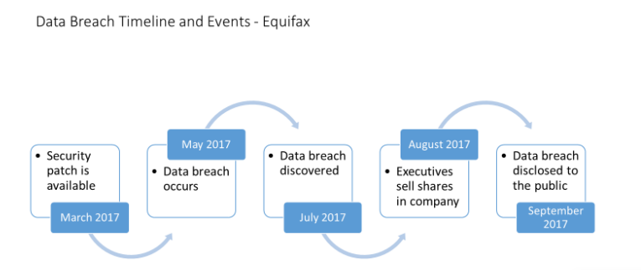

Breach Timeline:

* Mid-May to July 2017: Attackers exploited the Apache Struts vulnerability to gain initial access to Equifax's systems.
* July 29, 2017: Equifax discovered the breach.
* September 7, 2017: Equifax publicly announced the data breach.
* October 2017: Equifax revised the number of affected individuals from 143 million to approximately 147 million.
* Ongoing: Investigations and legal actions against Equifax by regulatory bodies and affected individuals.

**Data Compromised:**

The Equifax breach exposed highly sensitive personal information, including names, Social Security numbers, birth dates, addresses, and in some cases, driver's license numbers. Additionally, credit card numbers for approximately 209,000 individuals and dispute documents for approximately 182,000 individuals were compromised.

**Impact:**

The Equifax data breach had far-reaching consequences, both for individuals and the company itself:

* Identity Theft: The exposed personal information put affected individuals at significant risk of identity theft and financial fraud.
* Reputational Damage: Equifax faced severe public backlash due to the breach, damaging its reputation and customer trust.
* Legal and Regulatory Consequences: Equifax faced numerous lawsuits, investigations, and regulatory actions, resulting in substantial financial penalties and settlements.

**Response and Mitigation:**

Equifax's response to the breach was widely criticized for its handling of the incident:

* Delayed Disclosure: Equifax took over a month to disclose the breach publicly, raising concerns about transparency and accountability.
* Inadequate Remediation: The company struggled to provide timely and sufficient resources to affected individuals, causing further frustration.
* Executive Resignations: Following the breach, several senior executives, including the CEO, resigned from Equifax.

**Lessons Learned:**

The Equifax breach highlighted several critical lessons for organizations and the cybersecurity community:

* Patch Management: Regular and timely application of security patches is crucial to prevent known vulnerabilities from being exploited.
* Incident Response: Organizations should have robust incident response plans in place to detect, respond to, and recover from cybersecurity incidents effectively.
* Data Protection: The protection of sensitive customer data should be a top priority, requiring robust security controls and proactive measures.

**Conclusion:**

The Equifax data breach of 2017 served as a wake-up call for organizations worldwide, emphasizing the importance of cybersecurity and data protection. The incident underscored the need for proactive security measures, effective incident response plans. To secure the OSI model, organizations need to implement a comprehensive approach, including regular patching, network segmentation, strong encryption, access controls, and robust incident response plans. Protecting each layer of the OSI model is crucial to prevent unauthorized access and ensure data integrity and confidentiality. The incident serves as a reminder of the need for proactive security measures and transparency in the face of cyber threats.

**References:**

1. <https://www.cloudflare.com/learning/ddos/glossary/open-systems-interconnection-model-osi/>
2. <https://www.educba.com/what-is-osi-model/>
3. <https://www.byos.io/blog/types-of-cyber-attacks-osi>
4. <https://www.csoonline.com/article/564711/the-mirai-botnet-explained-how-teen-scammers-and-cctv-cameras-almost-brought-down-the-internet.html>
5. <https://sevenpillarsinstitute.org/case-study-equifax-data-breach/>
6. https://www.igbr.org/wp-content/uploads/articles/GJBP_Vol_3_No_3_2019-pgs-8-15.pdf